**Advance Excel Assignment 5**

**1. How many types of conditions are available in conditional formatting on Excel?**

There are 3 types of conditions available in conditional formatting on excel, AND, IF, OR.

**2. How to insert borders in Excel with Format Cells dialog?**

Select a cell or a range of cells to which you want to add borders. On the Home tab, in the Font group, click the down arrow next to the Borders button, and you will see a list of the most popular border types. Click the border you want to apply, and it will be immediately added to the selected cells.

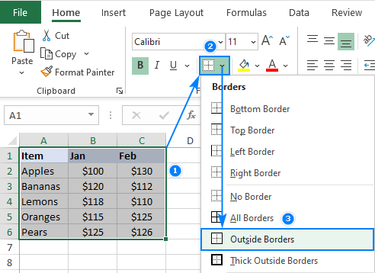

**3. How to Format Numbers as Currency in Excel?**

* Select the cells that you want to format and then, in the Number group on the Home tab, click the down arrow in the Number Format box.
* Choose either Currency or Accounting.

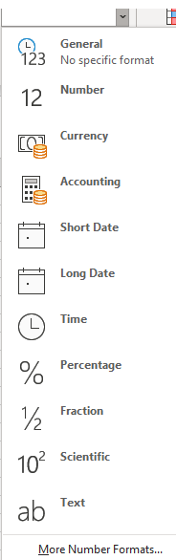

**4. What are the steps to format numbers in Excel with the Percent style?**

On the Home tab, in the Number group, click the icon next to Number to display the Format Cells dialog box.

In the Format Cells dialog box, in the Category list, click Percentage.

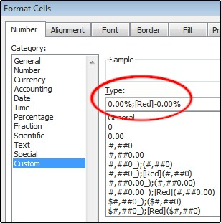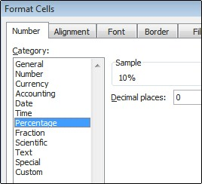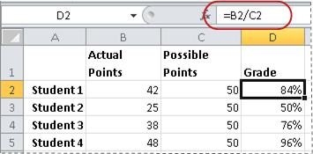

**5**. **What is a shortcut to merge two or more cells in excel?**

To merge two or more cells, highlight them and then press the following keys at the same time: **ALT H+M+M**.

Merge and center cells: If you would like to merge cells and center your text at the same time, you can highlight the cells and press these keys: **ALT H+M+C.**

**6.** **How do you use text commands in Excel?**

Select the column, or range where you'll be putting the values, then use **CTRL+1** to bring up the Format > Cells dialog and on the Number tab select Text.

Now Excel will keep your leading 0's. If you've already entered data and Excel has removed your leading 0's, you can use the TEXT function to add them back.